Introduction to Data Analytics

What is Data:
- Data refers to raw facts, observations, measurements, or records.
- It is collected or generated through various processes, such as transactions, interactions, observations, or experiments.
- In its raw form, data may lack context or meaning, but it serves as the foundation for information and knowledge when processed and analyzed.

Categories of Data:
- Structured Data:
  - Data that is organized into a predefined format, such as tables in a relational database, spreadsheets, or CSV files.
  - This is typically easy to search, query, and analyze because it follows a consistent schema.
- Unstructured Data:
  - Data that does not have a predefined structure or format, such as text documents, images, videos, social media posts, and sensor data.
  - Unstructured data may require more advanced techniques, such as natural language processing or computer vision, to extract meaningful insights.
Each piece of data can further be classified as below:
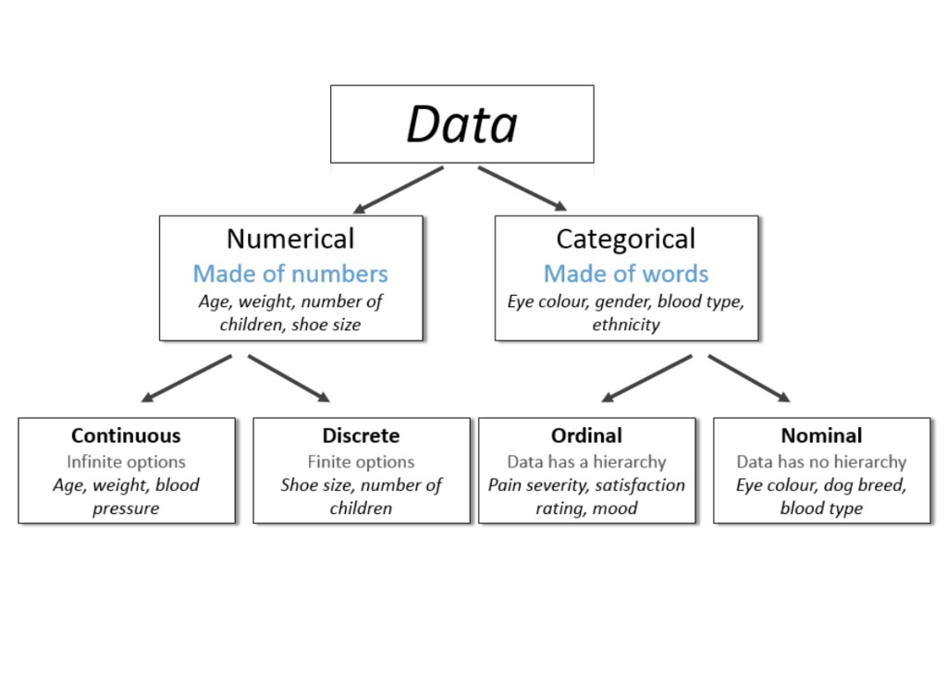

Data Growth:
- The volume of data created every day globally is estimated to be around 300-400 Million Tera Bytes per day.
- This is increasing exponentially day by day.
Several primary contributors drive this high volume of data creation:
- Internet Usage: The proliferation of internet-connected devices, including smartphones, tablets, computers, IoT devices, and more, leads to a constant stream of data generation through online activities such as social media interactions, web browsing, emails, and online transactions.
- Social Media Platforms: Social media platforms like Facebook, Twitter, Instagram, and TikTok generate vast amounts of data through user-generated content, interactions, shares, likes, comments, and more.
- IoT Devices: The Internet of Things (IoT) devices, such as smart home devices, wearable technology, sensors, and industrial machinery, continuously generate data through various sensors and monitoring systems.
- Business Transactions: Enterprises generate enormous volumes of data through their business operations, including sales transactions, customer interactions, financial transactions, supply chain activities, and more.
- Streaming Services: The popularity of streaming services for music, movies, TV shows, and gaming contributes significantly to data creation as users consume and interact with digital content.
- Research and Scientific Data: Scientific research, experiments, simulations, and observations generate vast amounts of data, especially in fields such as genomics, astronomy, climate science, and particle physics.
- Government and Public Sector: Governments and public sector organizations collect and generate data through various sources, including census surveys, administrative records, satellite imagery, and public service delivery.
- Digital Communication: Email communications, instant messaging, video conferencing, and other digital communication channels contribute to the continuous generation of data.

What is Data Analytics:
- Process of analyzing raw data to extract valuable insights and inform decision-making.
- It involves various techniques and methodologies to uncover patterns, trends, correlations, and other meaningful information from data sets.

How Data Analytics is Used:
- Data analytics is widely used across industries for various purposes, including improving business operations, optimizing marketing strategies, understanding customer behaviour, predicting trends, and driving innovation.
- It plays a crucial role in enabling data-driven decision-making and gaining a competitive advantage in today's data-driven world.
Example:
Coca-Cola, as one of the world's largest beverage companies, utilizes data analytics across various aspects of its business operations. Here's how Coca-Cola leverages data analytics:
- Demand Forecasting: Coca-Cola analyzes historical sales data, market trends, and consumer behaviour to forecast demand for its products. This helps in optimizing production schedules, managing inventory levels, and ensuring product availability in the market.
- Supply Chain Optimization: Data analytics is used to streamline Coca-Cola's supply chain operations, including procurement, manufacturing, distribution, and logistics. By analyzing data related to supplier performance, transportation routes, warehouse management, and inventory levels, Coca-Cola can improve efficiency, reduce costs, and minimize disruptions.
- Marketing and Consumer Insights: Coca-Cola collects and analyzes data from various sources, including social media, customer feedback, and sales transactions, to gain insights into consumer preferences, behaviour, and sentiment. This information informs marketing campaigns, product development strategies, and brand positioning efforts, allowing Coca-Cola to tailor its offerings to meet evolving consumer needs.
- Personalized Marketing: Coca-Cola employs data analytics to personalize marketing messages and offers for different customer segments. By segmenting consumers based on demographics, purchase history, and engagement patterns, Coca-Cola can deliver targeted advertisements, promotions, and product recommendations, increasing the effectiveness of its marketing efforts.
- Product Innovation: Data analytics plays a crucial role in Coca-Cola's product innovation process. By analyzing market data, consumer trends, and competitive intelligence, Coca-Cola identifies opportunities for new product development, flavor variations, and packaging innovations that resonate with target audiences and drive sales growth.
- Retail Execution: Coca-Cola uses data analytics to monitor and optimize its retail execution strategies, ensuring that its products are displayed prominently, priced competitively, and available in stores where demand is high. By analyzing retail sales data, shelf space allocations, and promotional effectiveness, Coca-Cola can maximize its presence and sales in retail outlets.
Overall, data analytics enables Coca-Cola to make data-driven decisions, improve operational efficiency, enhance customer engagement, and drive innovation, ultimately contributing to its continued success in the global beverage market.

Typical roles in Data Analytics:
Data Analyst
Financial Analyst
Logistics Analyst
Business Analyst
Statistician
Product Analyst
Operations Analyst
Marketing Analyst
Risk Analyst
Data Analytics Consultant etc.

Key Components of Data Analytics:
- Data Collection: The first step in data analytics involves gathering data from various sources, including databases, spreadsheets, sensors, social media, weblogs, and IoT devices. Data can be structured (e.g., databases, spreadsheets) or unstructured (e.g., text, images, videos), and it may come from internal or external sources.
- Data Preprocessing: Once collected, raw data often needs to be preprocessed to ensure its quality and usability for analysis. This involves tasks such as cleaning the data to remove errors and inconsistencies, handling missing values, standardizing formats, and transforming the data into a suitable structure for analysis.
- Data Analysis: The core component of data analytics involves analyzing the data to uncover patterns, trends, correlations, and insights. This can be done using various techniques and methodologies, including statistical analysis, machine learning algorithms, data mining, text analytics, and predictive modeling.
- Data Visualization: Data visualization is the process of representing data visually using charts, graphs, maps, and other graphical elements. Visualization helps in exploring and understanding the data, communicating insights effectively, and making data-driven decisions. Common tools for data visualization include Tableau, Power BI, matplotlib, and ggplot2.

Tools for Data Analysis:
- Excel: Excel is a widely used tool for data analysis due to its accessibility, versatility, and familiarity to many users. While Excel is a powerful tool for data analysis, it may have limitations when dealing with very large datasets or complex analytical tasks.
- Database Management Systems (DBMS):
  - MySQL: MySQL is an open-source relational database management system (RDBMS) commonly used for storing and managing structured data.
  - Oracle SQL: This is provided by Oracle
  - PostgreSQL: PostgreSQL is another open-source RDBMS known for its advanced features, extensibility, and support for SQL queries.
  - MongoDB: MongoDB is a NoSQL database that stores data in flexible, JSON-like documents, making it suitable for handling unstructured or semi-structured data.
- Programming Languages:
  - Python: Python is widely used for data analysis and machine learning tasks. Libraries like Pandas, NumPy, and SciPy provide powerful tools for data manipulation, analysis, and statistical modeling.
  - R: R is another popular programming language for statistical computing and graphics. It offers a wide range of packages for data visualization, statistical analysis, and predictive modeling.
- Data Visualization Tools:
  - Tableau: Tableau is a powerful data visualization tool that allows users to create interactive dashboards and visualizations from various data sources.
  - Power BI: Power BI is a business analytics tool by Microsoft that enables users to visualize and share insights from their data through interactive reports and dashboards.
- Big Data Tools:
  - Hadoop: Apache Hadoop is a framework for distributed storage and processing of large datasets across clusters of commodity hardware. It includes components like Hadoop Distributed File System (HDFS) and MapReduce.
  - Spark: Apache Spark is a fast and general-purpose cluster computing framework that provides in-memory data processing capabilities for large-scale data analytics and machine learning tasks.
  - Hive: Apache Hive is a data warehouse infrastructure built on top of Hadoop that provides SQL-like query language (HiveQL) for querying and analyzing large datasets stored in Hadoop.
- Machine Learning Platforms:
  - TensorFlow: TensorFlow is an open-source machine learning platform developed by Google for building and deploying machine learning models.
  - scikit-learn: scikit-learn is a Python library for machine learning that provides simple and efficient tools for data mining and data analysis.
  - Keras: Keras is a high-level neural networks API written in Python that allows for easy and fast prototyping of deep learning models.

Types of Analysis:
- Descriptive Analysis: Descriptive analysis involves summarizing and describing the main features of a dataset, such as its central tendency, dispersion, and distribution. Descriptive statistics, charts, and graphs are commonly used to present key characteristics of the data.
- Diagnostic Analysis: Diagnostic analysis focuses on identifying the causes of observed patterns or outcomes in the data. It involves analyzing relationships between variables, identifying correlations, and conducting root cause analysis to understand why certain events occur.
- Predictive Analysis: Predictive analysis involves using historical data to make predictions about future events or outcomes. It includes techniques such as regression analysis, time series forecasting, and machine learning algorithms to build predictive models and estimate the likelihood of future events.
- Prescriptive Analysis: Prescriptive analysis involves recommending actions or decisions based on the insights gained from data analysis. It aims to optimize outcomes by identifying the best course of action given the available data and constraints. Optimization techniques, decision trees, and simulation models are commonly used for prescriptive analysis.

